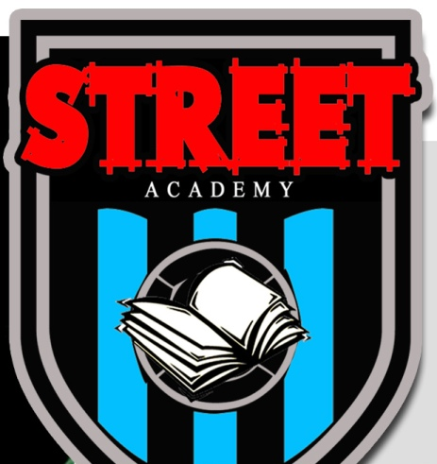
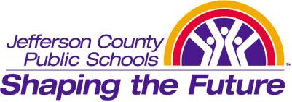

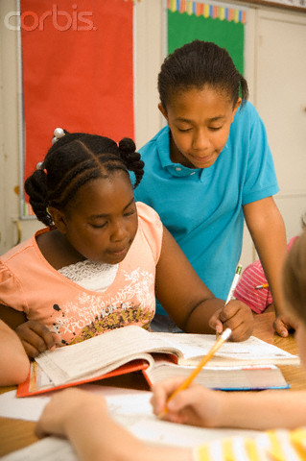
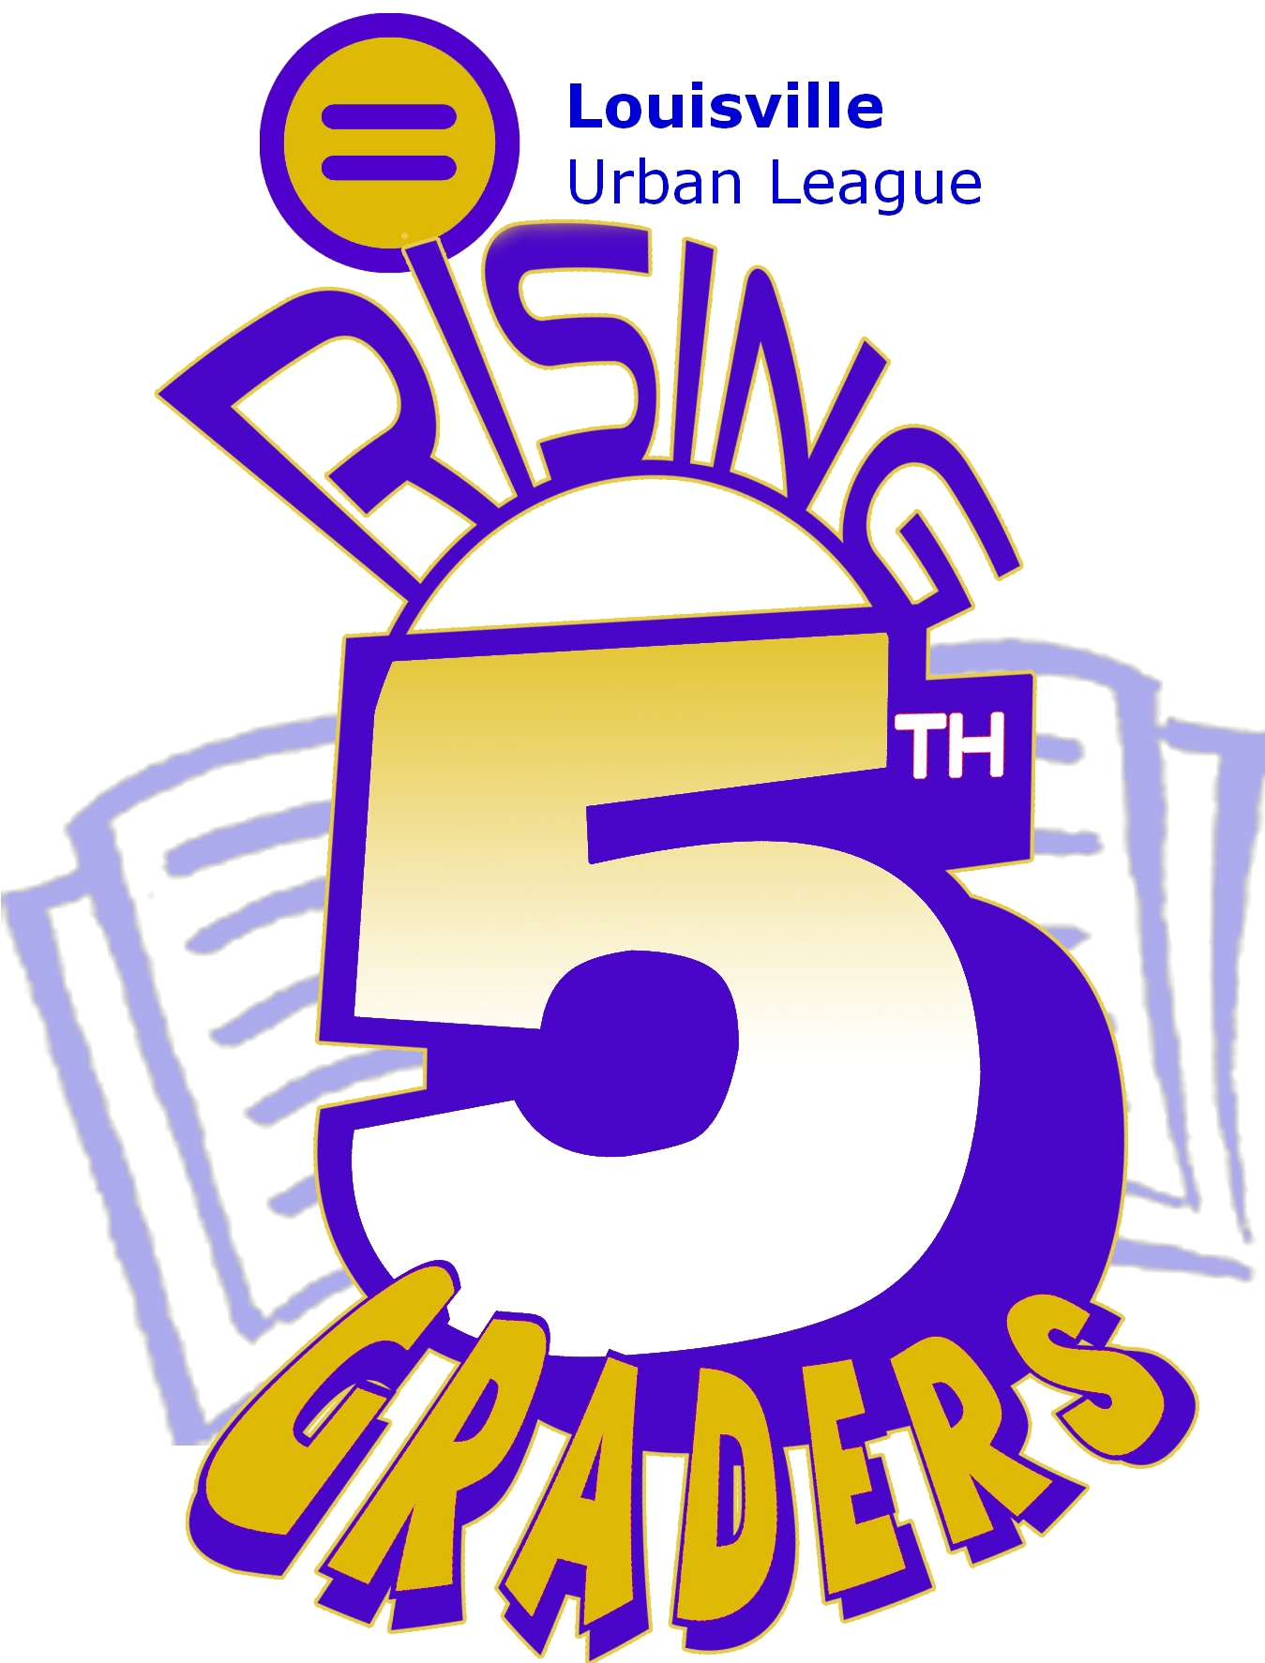
SATURDAY YOUTH PROGRAMS
Offered at Phillis Wheatley Elementary
1107 S. 17th Street
- Rising 5th Graders is a literacy program for 4th, 5th and 6th grade boys and girls.

- It meets on most Saturday mornings from 9am until 12 noon during the school year.

- R5G offers instruction in reading and comprehension and assists the student with gaining proficiency in all elements of literacy.

- Bus transportation is available to and from the program if your child lives in zip codes 40202, 40203, 40208, 40210, 40211, 40212.

- Your child will be provided a snack during the program.
- Street Academy is a literacy program for 4th, 5th and 6th grade boys from Title I schools

- It meets on most Saturday afternoons from 1:00pm until 4:30 during the school year.

- SA offers instruction in reading and comprehension and assists the student with gaining proficiency in all elements of literacy. It also has a behavior development component.

- Bus transportation is available to and from the program if your child lives in zip codes 40202, 40203, 40208, 40210, 40211, 40212.

- Your child will be provided a snack during the program.
PLEASE CALL 502-566-3383 OR EMAIL: imuhammad@lul.org
FOR MORE INFORMATION ON ENROLLING YOUR CHILD
IN EITHER OF THESE FREE SATURDAY PROGRAMS

